NEXTAG COMPANY

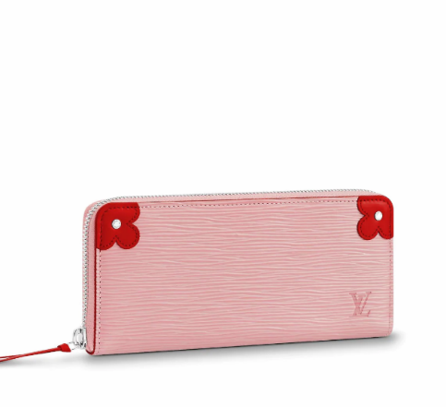LOUIS VUITTON - CLÉMENCE WALLET

##### **Detail**

For the Epi Blooming Corners limited edition, the Clémence wallet comes in Epi leather with contrasting Monogram flower-shaped corners. This detail, which was inspired by historic Louis Vuitton trunks, brings a fresh, playful note to this elegant long wallet, whose secure zip-around format conceals a variety of pockets and credit card slots.

• Epi cowhide leather in pale-pink Rose Ballerine

• Cowhide-leather lining

• Silver-color hardware

• 8 CC slots

• 1 zipped coin pocket

##### • 20.0 x 9.0 x 2.0 cm (Length x Height x Width)

##### **CARE & COMPOSITION**

* leather
* imported